* Expression can be a arithmetic operation or logical operation or method call or instatiation that gives some data to display.

Standard syntax:

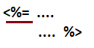

Xml syntax:

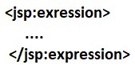

* The code which is placed in expression tag goes to out.print(-) method as argument value in the _jspService(-) method of JES class.
* If the expression tag is used effectively there is no need to using out.print(-), out.println(-) in our jsp page.
* We can not place following things in expression tag.

1. Class definition
2. Interface denitiation
3. Method definitation

Because java does not support to write these definitations as argument values.

* For expression placed in expression tag.. we must not place “;” symbol because the code goes to arg value of out.print(-) method, so placing “;” for arg value is syntactically invalid.

1. Performing arithmetic and logical operations using expression tag

=============================================

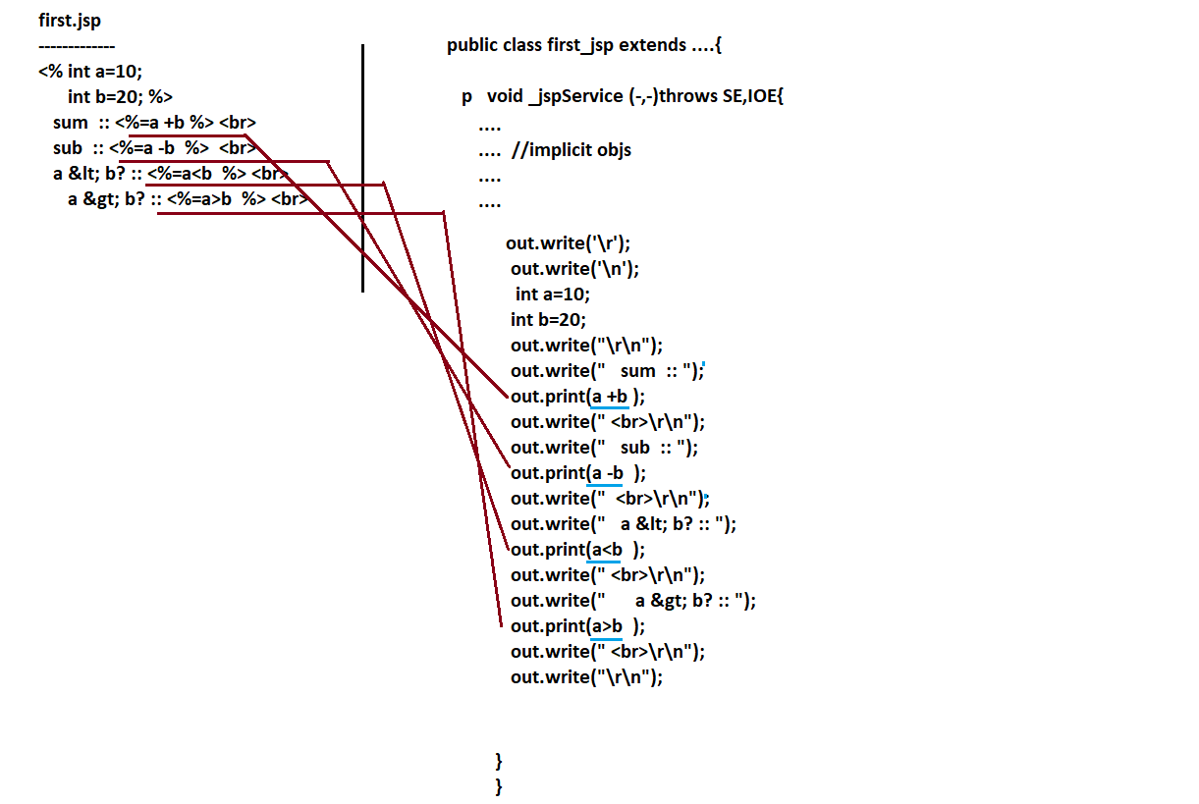

1. Using expression tag we can invoke method and we display generated results on browser.

==================================================

Note:- Using expression tag, we can call only those methods whose return type is other than void.

We should not write method definition in expression tag.

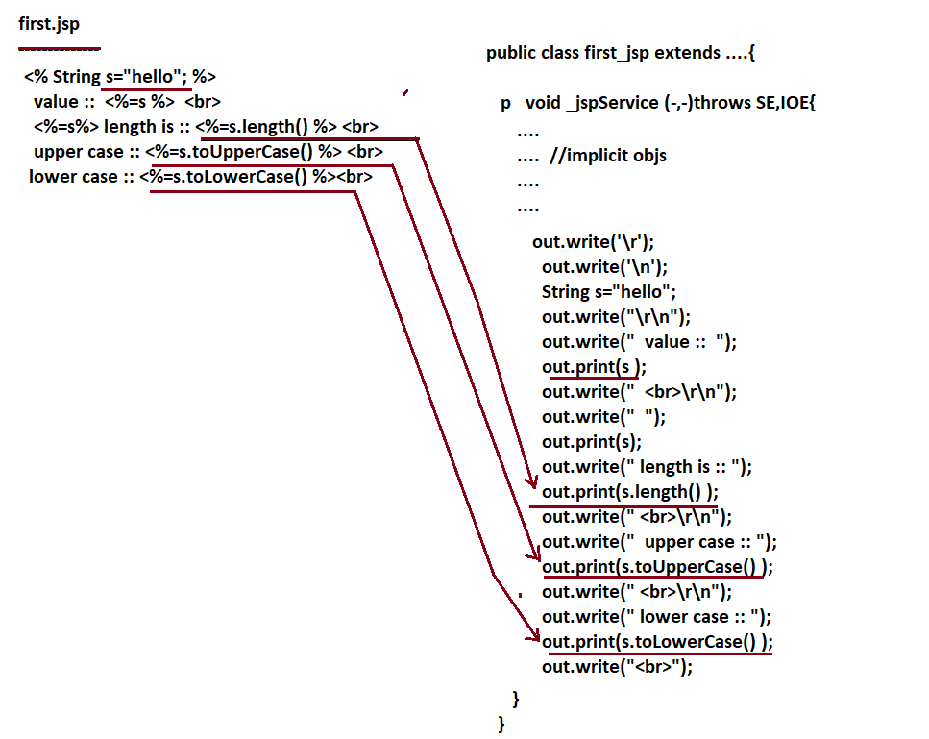

3.The implicit objs can be used in expression tag becoz they are local variables of _jspService(-,-) method and code placed expression tag also goes to _jspService(-,-) method.

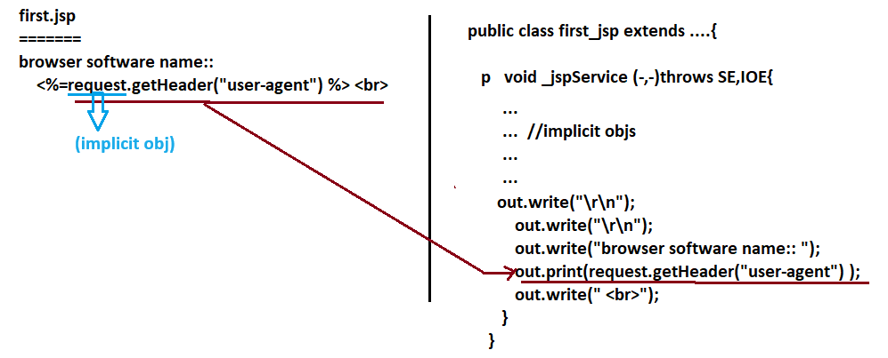

4.XML syntax:-

===========

Example:-

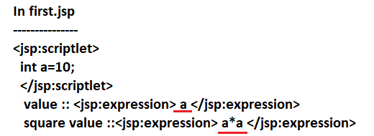

For “<” symbol problem there is no solution in the xml syntax of expression tag.

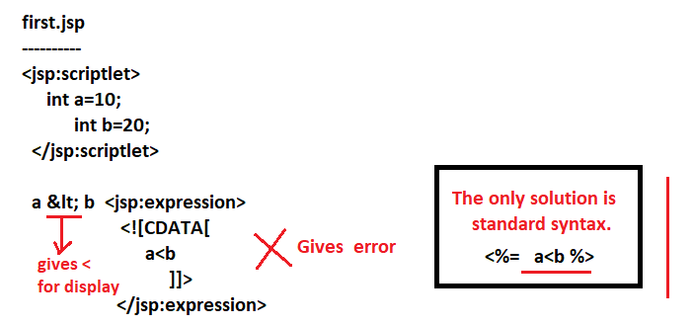

* We can use both standard and xml syntax for jsp tags in single jsp page.
* One jsp page can have 0 or more expression tags either with only standard syntax or with only xml syntax or with both syntaxes.
* Nested expression tags are not allowed at any cost.

5. What is diff between out.write(-) and out.print(-) method?

